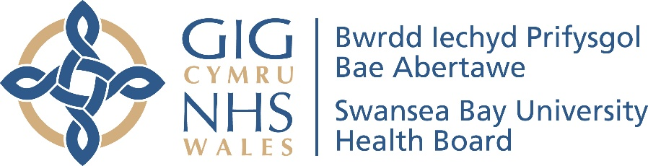

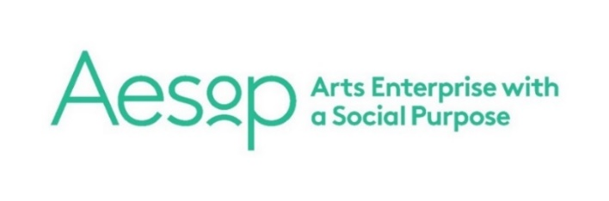 | 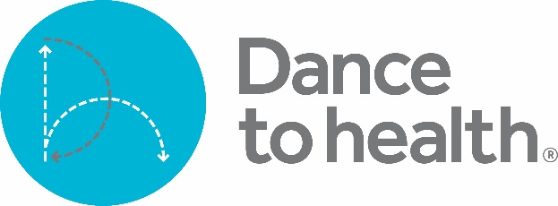

Dance to Health in Wales

Introduction
Dance to Health (https://www.dancetohealth.org/) is a pioneering falls prevention dance programme for older people. It has been developed by Aesop to show that an arts intervention can address a major health challenge
and go to scale in the health system.  Dance to Health combines evidence-based falls prevention principles with the creativity, expression and energy of dance. Sessions are led by dance artists from leading dance companies who have qualified in falls prevention exercise. | 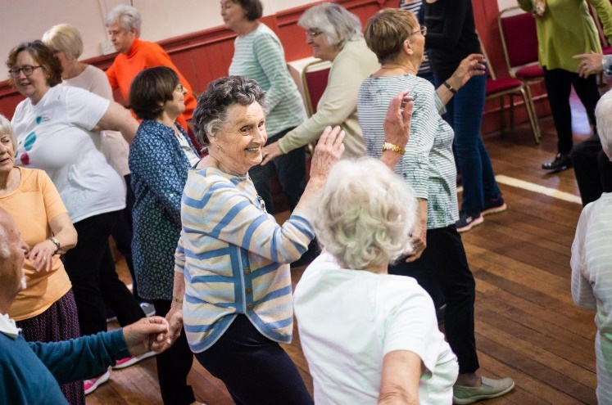
An evaluation by Sheffield Hallam University (https://ae-sop.org/wp-content/uploads/sites/63/2019/06/SHU-SIRC-1st-report-FINAL.pdf) has concluded that ‘Dance to Health offers the health system a more effective and cost-effective means to address the issue of older people’s falls’.

What, who, where, when…
On a Tuesday afternoon at The Institute in Pontarddulais you will find around 50 older people exercising to music in a group which is led by an experienced Dance Artist. Volunteers will be serving refreshments and collecting data for research. Prue Thimbleby, the Health Board’s Arts in Health Co-ordinator, and Alyson Pugh, Dance to Health’s Local Co-ordinator, have dropped in to monitor the session and catch up with participants and volunteers.

The story so far
Aesop ran a successful Dance to Health pilot project in 2015 and 2016. The current £2.1 million ‘Phase 1 Roll-out [test and learn]’ began in April 2017 and
finishes this month. Swansea Bay Health Board is the Welsh Health Partner
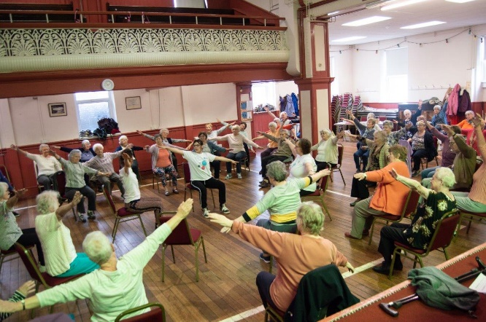 |  |  | and the National Dance Company Wales, the Dance Partner. Phase 1 began with six ‘Improvement Programmes’ – dance versions of the evidence-based Otago and FaME falls prevention exercise programmes. Four Welsh dance artists completed the same falls prevention exercise training that physios do to become ‘Postural Stability Instructors’. They then learned how to smuggle the
exercises into dance. The six Improvement Programmes each lasted the required six months and were followed by setting up three maintenance programmes where the participants, volunteers and the local community have developed financially sustainable, weekly falls prevention dance groups. As well as Pontarddulais, there are groups in Gorseinon and Porthcawl.
The future – ‘Phase 2 Roll-out’ in Wales
Spurred on by the successes of Phase 1 and data showing that 1,000s of older people in the Swansea Bay UHB area could benefit from Dance to Health, the plan over the next four years is to:  - Create 80 volunteer-led, financially sustainable Local Dance to Health Groups in Wales, working with Local Partners and using a social franchise model. |  | 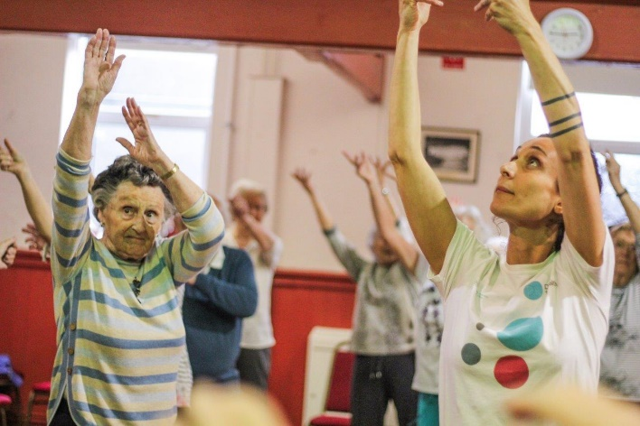
- Run Improvement Programmes for groups of older people at particular risk of falls and high reliance on the NHS and social care.
- Undertake a randomised controlled trial of Improvement Programmes and develop the dance dimension of the whole programme.
- Establish Dance to Health as a sustainable social enterprise, funded by:
  - Franchise fees for setting up new groups.
  - Annual support fees from established groups.
  - NHS fees to run Improvement Programmes.
  - Corporate sector partners (strategy approved by the Aesop Board).
  - Merchandising surpluses (to be developed).
